Yearly Plan - EYFS
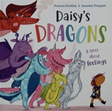

Autumn Term 1:
I wonder what makes us special and what I can do…
Mini Project: ‘It’s Not a Box’

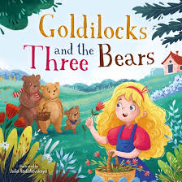
Autumn Term 2:

I wonder where the story will take us…
Event: Christmas Performance. Autumn Trip
Mini Event: Goldilocks crime scene
Festivals: Diwali and Christmas


Spring Term 1:
I wonder what’s out there…
Event: Space Dome
Mini Event: Space capsule

Festivals: Lunar New Year

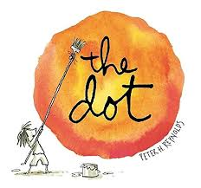
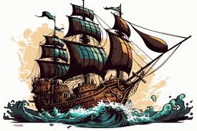
Spring Term 2:
I wonder where the journey will take us….
Event: Pirate Day. Book Day
Mini project: ‘The Dot’
Festivals: Easter.

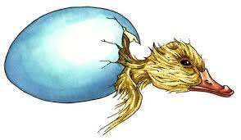
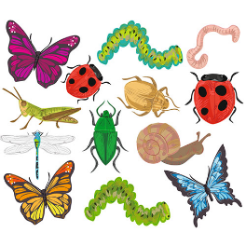
Summer Term 1:
I wonder how living things grow…
Event: Chick Day. Minibeast Hunt
Mini Project: Find eggs/How have I changed


Summer Term 2:
I wonder how others can help us…
Event: Superhero picnic.
Visits: Real life heroes. Summer trip

